CELEBRATION OF THE ARTS 2019
GIFT SHOP APPLICATION
Applications due Friday, August 16, 2019 No late applications can be accepted.
Applicant must be a RCVAG member.

Name
Email _____________________
Phone ___

Items or Category of items for sale: _
It is recommended that gift shop items be priced at $35 or less and avoid large, bulky or heavy items. Holiday themed or “gift” items work well. All items must be original and follow gallery guidelines. The standard sales commission for each sale will be applied (70%/30%).
Drop off / Check-in:
Bring your items (and display materials) to the ICC Foundation on Thursday September 12 between Noon and 4:00 p.m. Please check in at the table just outside the Gift Shop entrance. You will be instructed on where you are to set up your display. If you are not available to come that day, please designate someone to do it for you. Mark displays with your name or artist ID#.
Pick up: Wednesday Sept. 18 between 12 noon – 4:00 p.m. If you cannot pick up your work during this time, please arrange for someone else to do so. There is a $25 fee for work left after pick-up time (official COTA policy).
Display Format:
Merchandise will be organized by the artist. Each artist will find a table space of suitable size and set up their items as they wish. Table space will be on a first come basis. If easels are needed, the artist must furnish them.
Price Tags:
Use the same price tag numbering procedures as you use at the Art Guild VAC store. Each item for sale must have a price tag using the RCVAG system containing your Artist ID# (this includes your initials and your artist number) and your 3 digit Item #. Example: BP-120-131.
Inventory Sheet:
Please list items on the standard VAC Inventory Sheet Form and bring along with your merchandise. Multiples of similar items at the same price should be listed together as one item, then indicate the quantity in the quantity column. Example: 10 bracelets for $10 is listed with one item # with Quantity 10
Important: Items removed from the Art Guild for the show must be listed on a separate inventory sheet marked “Temporary Removal” and left at RCVAG office.
The undersigned hereby agrees to abide by the terms and conditions outlined in VAC consignment agreement and understands that the VAC does not carry insurance and releases and holds harmless the Rutherford County Visual Artists Guild, The Visual Arts Center and their agents.
Signed ______________________________________Date ___________________________

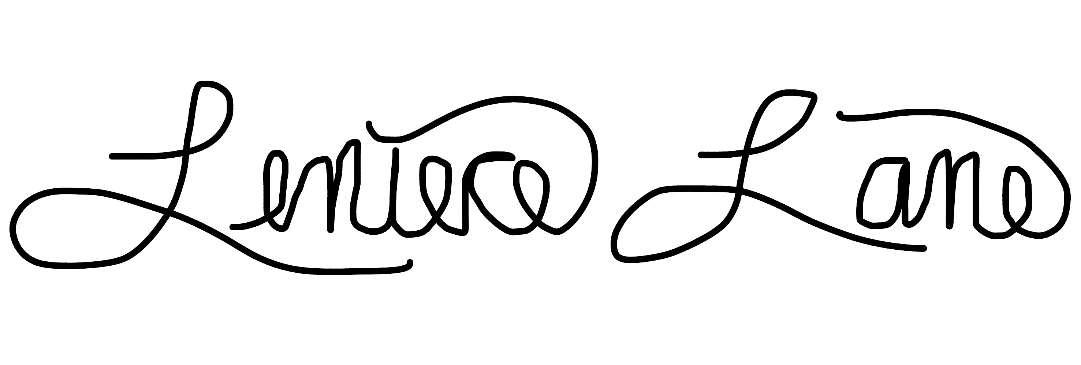
Submit Application by Friday, Aug 16, 2019 by Email: rcvartg@gmail.com add “COTA Gift Shop” to subject line. By Mail: RCVAG, PO Box 2015, Rutherfordton, NC 28139 -or- Dropped off at the VAC.

