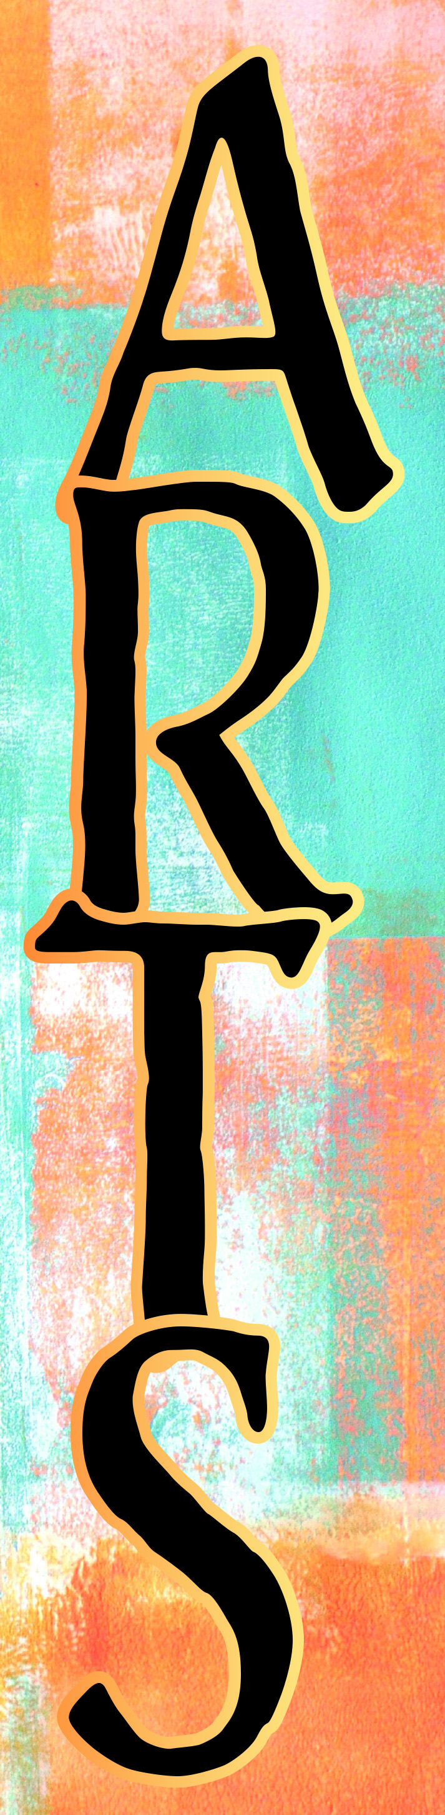


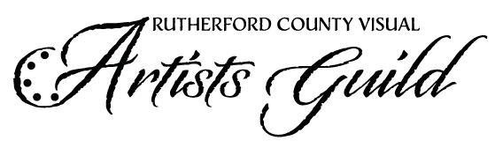
This show is supported in part by the NC Arts Council,
a division of the Department of Cultural Resources,
Stonecutter Foundation, the Lake Lure Artist and
The Tryon Painters and Sculptors

Application for Show
September 13 - 18, 2019

At the Foundation Conference and
Performing Arts Center
Isothermal Community College, Spindale, NC

Artist Application Deadline
August 16, 2019
Art Show & Gift Shop
Silent Auction
Junior Art Show- separate application
Applications available at www.artatthevac.com
and
The Visual Arts Center

2019 CELEBRATION OF THE ARTS
Show Location: The Foundation for the Performing Arts at Isothermal Community College, Spindale, NC
Times:
September 12 - Check In with Art for show 10am - 3pm
September 13 through 17 9am -5pm, except Sunday 1pm-4 pm
September 18 9am -1pm
September 18 – Artist pick up noon – 4pm
Eligibility: Open to all artists (Not restricted to RCVAG members or Rutherford county residents.)
First Time COTA Participants: First time exhibitors in COTA must include photos of the artwork being entered in the show with the application. Digital photos may be submitted on disk or emailed to rcvartg@gmail.com. Include artist name and “Celebration application” in the subject line.
Requirements: Entries must be original works of the artist and completed within the last two years. Artwork cannot have been previously displayed at COTA. Items made from kits, commercial molds, patterns, or instructor-assisted works are not allowed.
Maximum Number of Art Pieces: Each artist may enter a total of four pieces. Artwork may be 2D or 3D or a combination and must be indicated on the application. Artists entering 2D art exceeding 36” x 48” must supply their own easel or stand and must make a notation on the application.
Display Requirements: Framed artwork must be wired with D-rings. Saw tooth hangers, clip frames or screw eyes will not be accepted. Canvases without a frame must be gallery wrapped. Artwork deemed inappropriate for this venue by the COTA Chair or committee will not be displayed.
Questions about specifications, contact RCVAG.
828-288-5009 or rcvartg@gmail.com

Awards: Best in Show - $200
1st Place - $100 (2D and 3D)
2nd Place - $75, (2D and 3D)
3rd Place - $50 (2D and 3D)
Awards of Merit Ribbons
Sales: Art for sale must have price listed.
Art that is sold during the show must remain for the entire show. Buyer may pick up 1pm - 4pm on Wednesday, September 18. Works that are not for sale should be listed as NFS.
Commission: RCVAG will retain a 30% commission on sales.
Liability: RCVAG does not carry insurance
and assumes no liability for damage or loss. Artists must insure their own work. The delivery of an entry constitutes an agreement by the artist to this policy.
Marketing: RCVAG reserves the right to use photographs of the show artwork and/or artists to promote the Celebration of the Arts.
Drop-off: - Thursday, September 12, 2019,
10 am – 3 pm at The Foundation for the Performing Arts at Isothermal Community College, Spindale, NC.
LATE ENTRIES WILL NOT BE ACCEPTED. .
Pick up: Wednesday September 18, noon – 4pm. If you cannot pick up your work at this time, arrange for someone else to do so. THERE WILL BE A $25 FEE CHARGED FOR WORK LEFT AFTER PICK UP TIME.
Artists Reception: A Reception and Awards Ceremony for participating artist and one guest plus donors, sponsors and RCVAG members and one guest on Friday September 13, 6:30pm – 8:30pm
Participation: To help make the show a success, participation is needed from entrants. Information will be sent with acceptance letter.


Cut here and mail application, check, and photos (if applicable)* to:
RCVAG, PO Box 2015, Rutherfordton, NC 28139, or drop off at the
Visual Arts Center, 160 N Main St, Rutherfordton, NC. (Tues. – Sat., 10 am – 3 pm)
*Photos can be emailed to rcvartg@gmail.com
Make check out to: RCVAG Mark check: Celebration in “For” line.


ARTWORK # 1
Artist:
Title:
Medium:Category: ◻ 2D ◻ 3D Price:
ARTWORK # 2
Artist:
Title:
Medium:Category: ◻ 2D ◻ 3D Price:
ARTWORK # 3
Artist:
Title:
Medium:Category: ◻ 2D ◻ 3D Price:
ARTWORK # 4
Artist:
Title:
Medium:Category: ◻ 2D ◻ 3D Price:
APPLICATION: COTA

◻ RCVAG Guild Member Entry Fee - $25
◻ Non-Guild Member Entry Fee - $35
Please PRINT:
Name:
Address:
City, State, Zip:
Phone(s):
Email:

All applications must be submitted by Friday, August 16, 2019
No Late Applications will be accepted!

